 VINOD SIR’S GROUP TUTION

MARKS: 24 MATHS-VII TIME: 1 HOUR

Q. 1: Fill in the blanks for the following: [3]

1. 6 + 8 = _______ 2. 10 + (-6) = _______ 3. - 6 + 4 = _______
4. (-8) + (-5) = _______ 5. (+9) – (+4) = _______
6. (+11) – (-6) = _______

Q. 2: Write a number in each bracket to obtain the answer ‘5’ in each operation. [3]
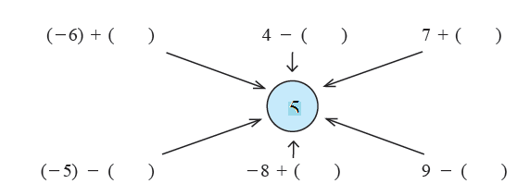
Q. 3: Complete the following table: [3]
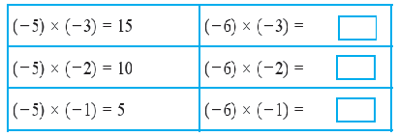
Q. 4: Multiply the following: [5]

(i) (-5) × (-7) (ii) (-9) × (6) (iii) (9) × (-4)
(iv) (8) × (-7) (v) (-124) × (-1) (vi) (-12) × (-7)
(vii) (-63) × (-7) (viii) (-7) × (15)

Q. 5: Solve the following: [10]

(i) (- 96) ÷ 16 (ii) 98 ÷ (- 28) (iii) (- 51) ÷ 68
(iv) 38 ÷ (- 57) (v) (- 85) ÷ 20 (vi) (-150) ÷ (- 25)
(vii) 100 ÷ 60 (viii) 9 ÷ (- 54)

